**MANSI UNIYAL**

**19EE10039**

**Single Phase Inverter:**

1. **a.**

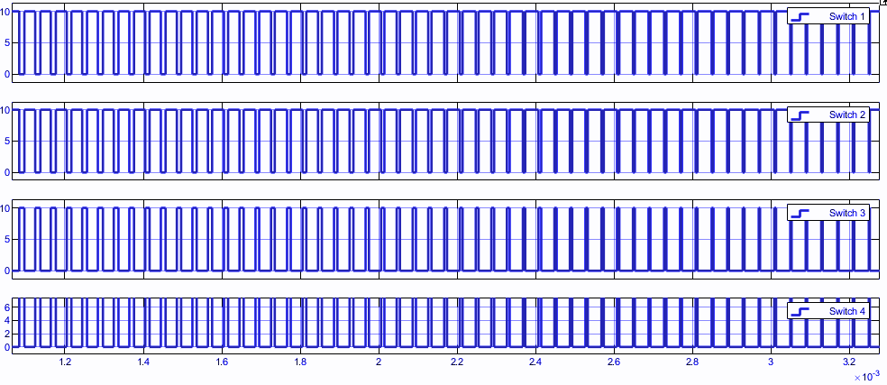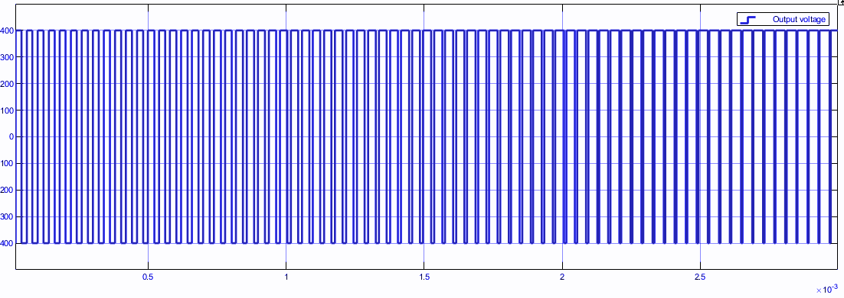

Switch Currents Output Voltage

(Peak of modulating signal = 0.98)

**b.**

(i)

Total Harmonic Distortion = 104.10%

Magnitude of fundamental component = 391.5 V

(ii)

5th = 0.117 V(0.03%)

7th = 0.195 V(0.05%)

**c.**

For displacement factor = 0.8 lagging ie inductive

L=0.095

Displacement factor=1

Impedance =resistive

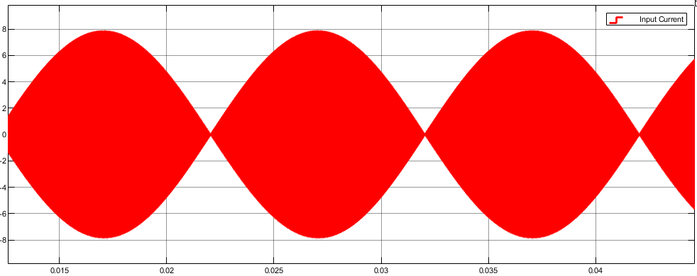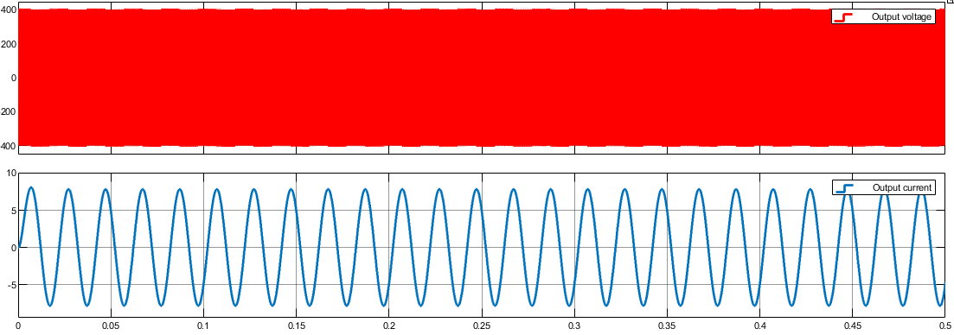

Displacement factor=0.2

Impedance =capacitive

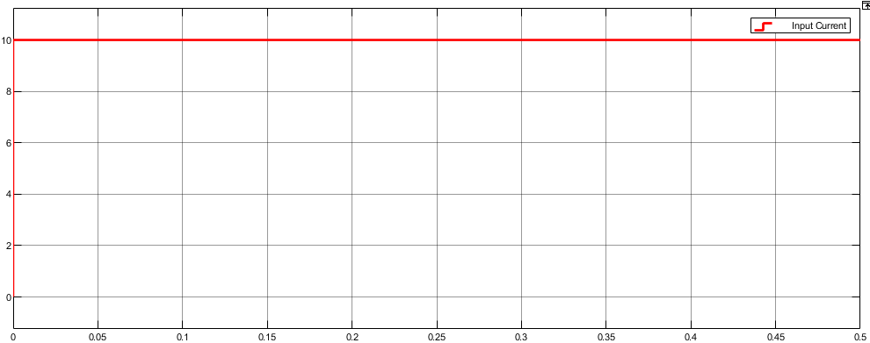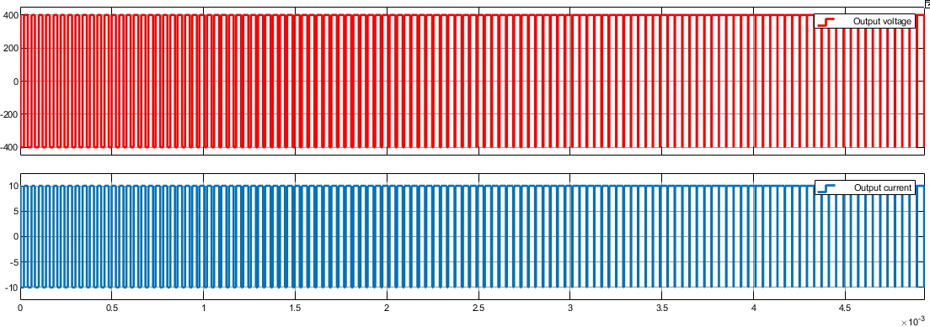

C=16.24uF

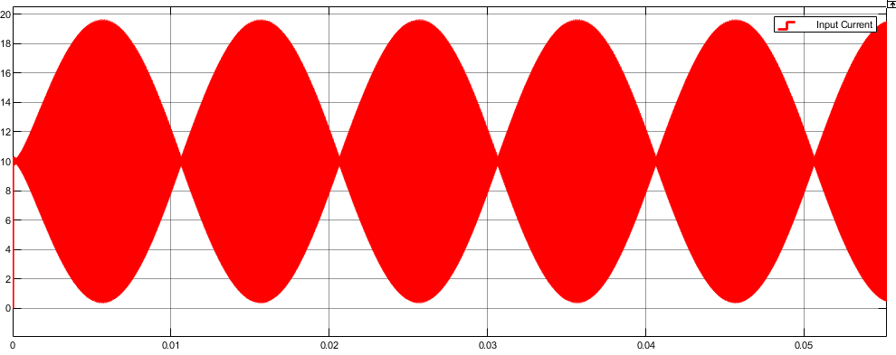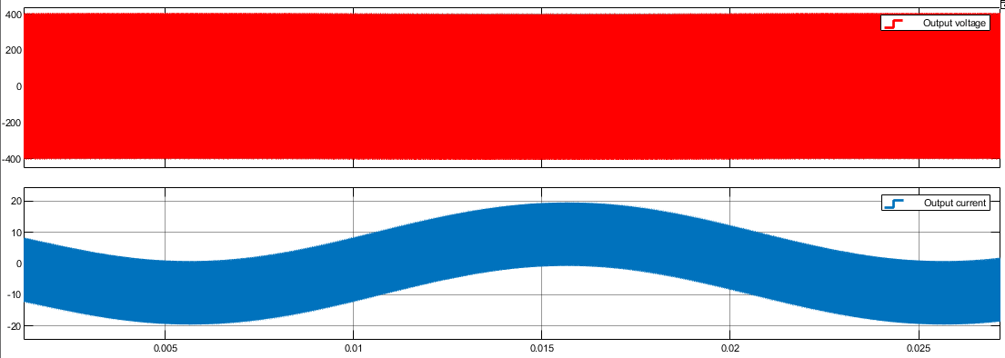

________________________________________________________________________________________________________________________________________________________

**Three Phase Inverter:**

1. (i) ma=0.4

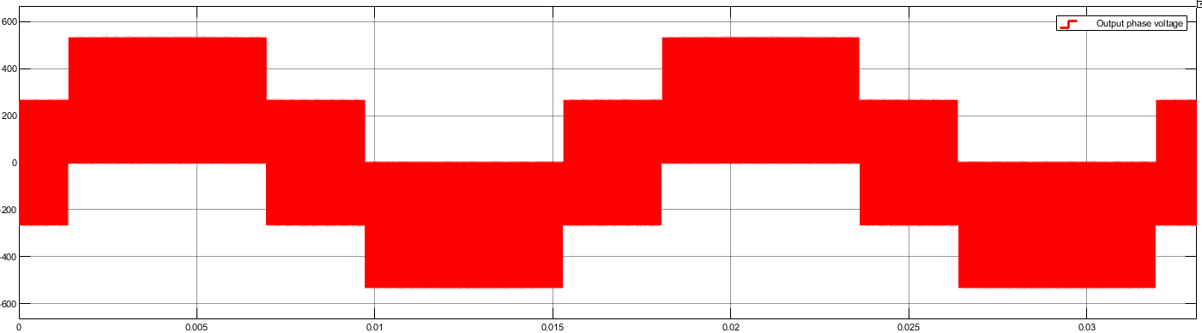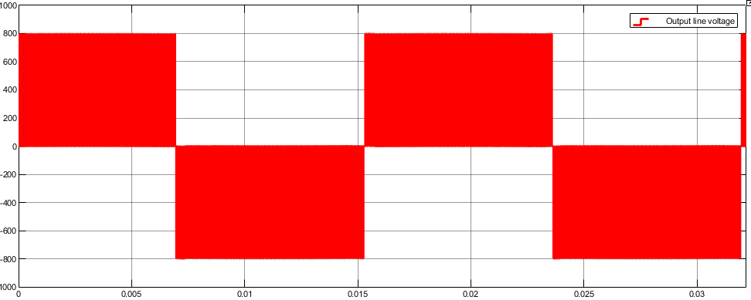

(ii) ma=0.8

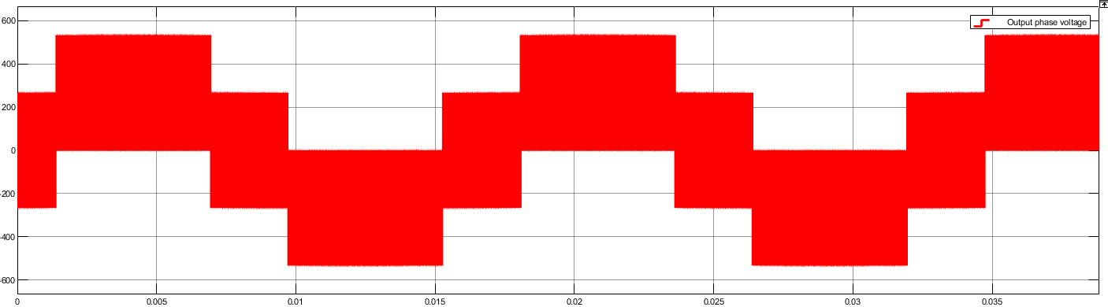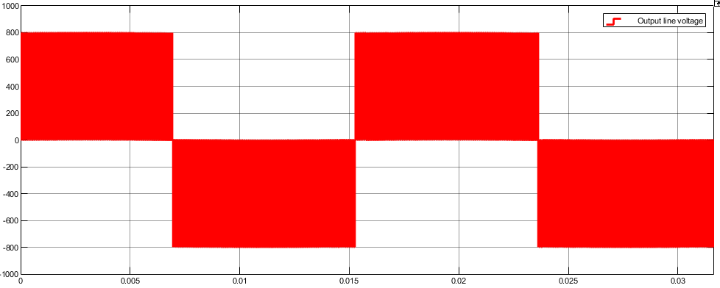

(iii) ma=1.2

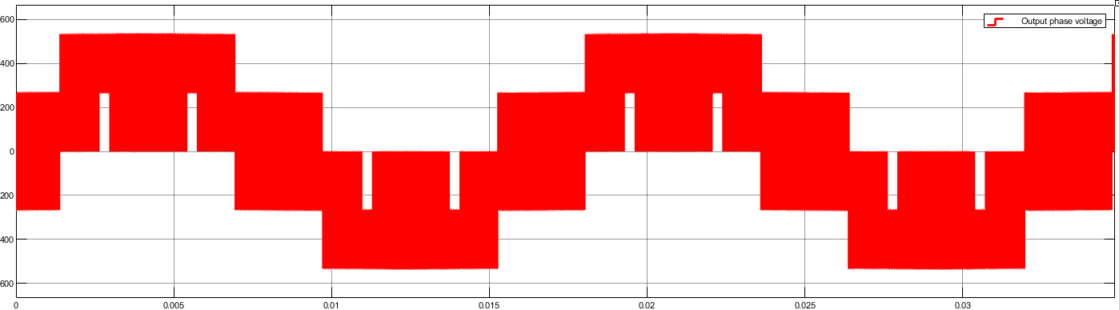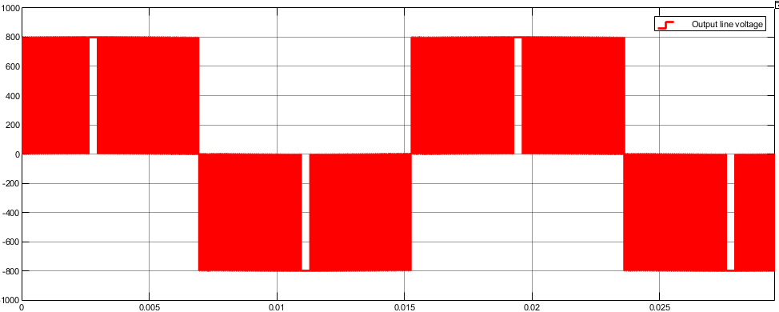

| **ma** | **0.4** | **0.8** | **1.2** |
| --- | --- | --- | --- |
| Fundamental Component RMS (Line voltage) | 84.86V | 391.6V | 540.8V |
| THD(Line Voltage) | 197.53% | 91.62% | 58.19% |
| Fundamental Component RMS (Phase voltage) | 147V | 226.1V | 312.2V |
| THD(Phase Voltage) | 197.53% | 91.61% | 58.18% |

**b.** Fundamental Component RMS (Line voltage)=317.2V

THD(Line Voltage)=113.74%

Fundamental Component RMS (Phase voltage)=183.1V

THD(Phase Voltage)=113.74%

**c.**

| **ma** | **0.1** | **0.5** | **1.0** |
| --- | --- | --- | --- |
| **fm** | **6Hz** | **30Hz** | **60Hz** |
| Fundamental Component RMS (Line voltage) | 317.2V | 244.9V | 489.5V |
| THD(Line Voltage) | 113.74% | 139.34% | 68.84% |
| Fundamental Component RMS (Phase voltage) | 183.1V | 141.4V | 282.6V |
| THD(Phase Voltage) | 113.74% | 139.34% | 68.84% |